Chapter 9, Solution 66.

For the circuit in Fig. 9.73, calculate Z_{T} and V_{ab}.

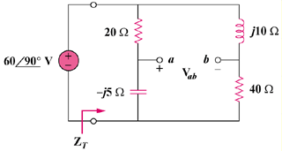

Figure 9.73
For Prob. 9.66.

Solution
14.069 – j1.172 = 14.118-4.76

+

V_{ab}

j10

20

I₂

I₁

I

52.94273 V

